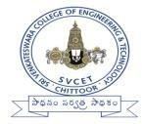
RollNo.:

Sri Venkateswara College of Engineering & Technology, Chittoor (Autonomous)
Subject :Digital Logic & Computer Organization(23AEC06)
Class& Branch: II-I CSE Date: 10.10.2025 ASSIGNMENT: 5 Max.Marks:5 Marks

1. Explain the terms synchronous and asynchronous data transfer.
2. What is the difference between maskable and non-maskable interrupts?
3. What is the role of a handshaking signal in data transfer?
4. Explain the need for I/O interface circuits.

SUBMISSIONDATE:17.10.2025

